Lab Exercise 20- Deploy a Docker Application using AWS ECR and ECS
Name: Anshi Agrawal
SAP ID: 500124498
Batch: 1 DevOps

1. Objective
In this lab, you will learn how to:
- Build a container image using Docker
- Store the container image in Amazon Elastic Container Registry
- Deploy the container on Amazon Elastic Container Service
- Access the running application through a public endpoint

2. Prerequisites
Before starting the lab, ensure you have:
- AWS account with appropriate permissions
- Docker installed
- AWS Command Line Interface installed and configured
- Basic understanding of containers
- Internet access

3. Lab Scenario
A development team has built a small web application using containers.
Your task as a DevOps engineer is to:
- Containerize the application using Docker
- Store the container image in Amazon ECR
- Deploy the container to Amazon ECS
- Verify the application is running successfully

4. Lab Tasks
Step 1: Create ECR Repository
- Go to AWS Console
- Search Elastic Container Registry (ECR)
- Click Create Repository
- Give name (example: my-web-app)
- Click Create

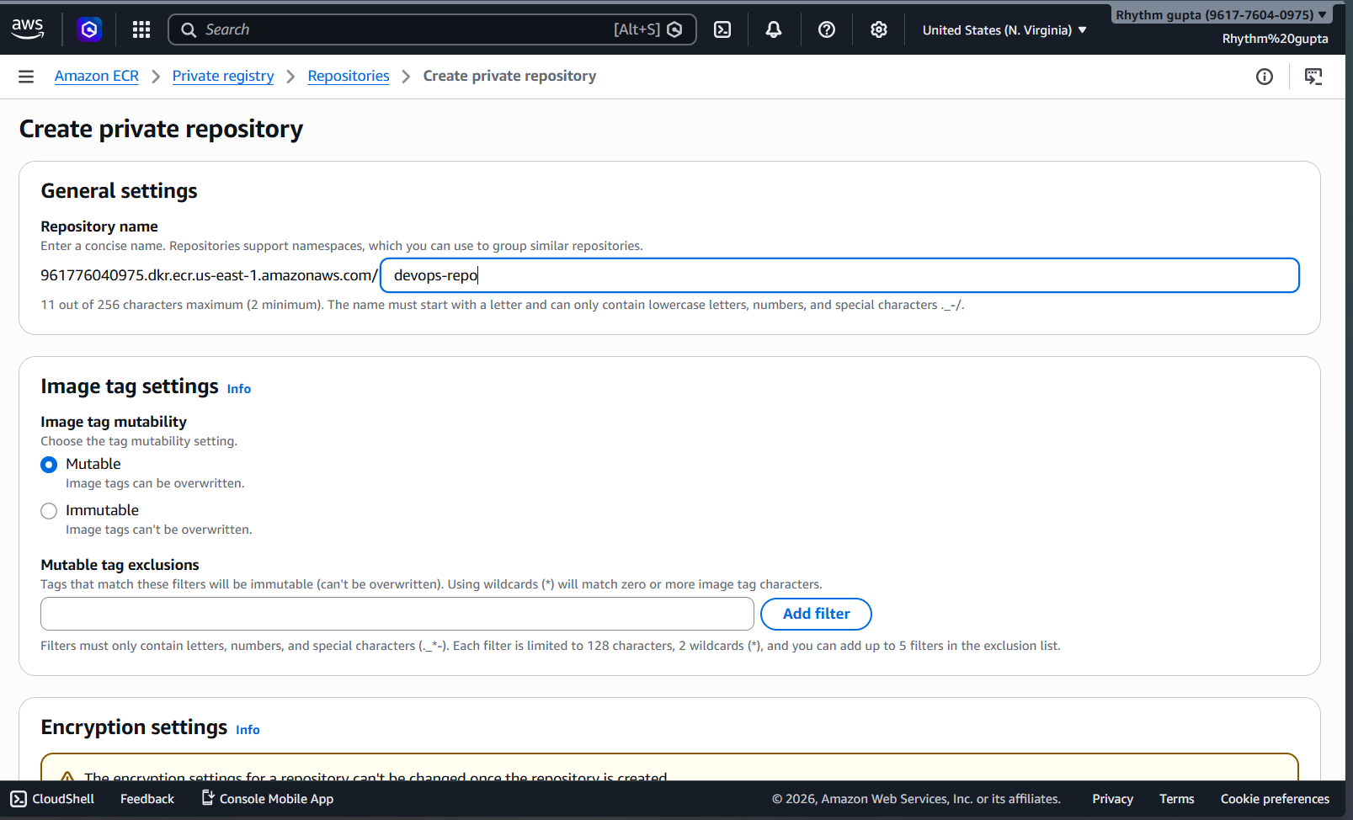

Step 2: Configure aws
Create access key
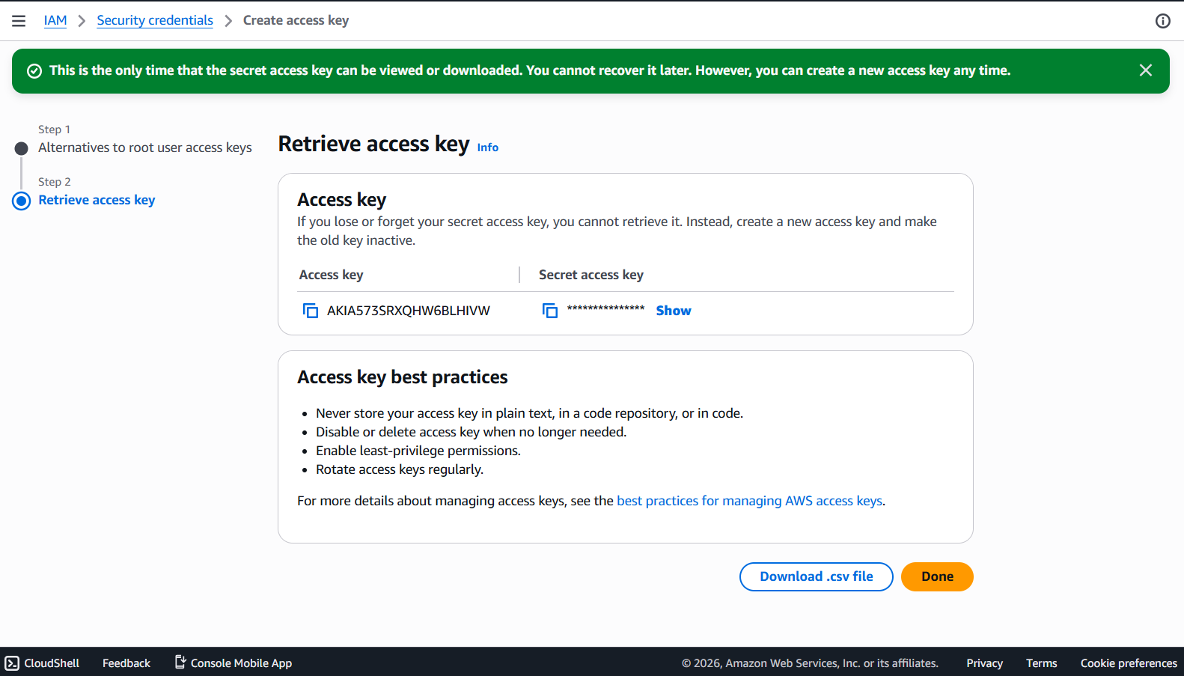
Step 3: Authenticate Docker to ECR
Run this :
aws ecr get-login-password --region us-east-1 | docker login --username AWS --password-stdin 961776040975.dkr.ecr.us-east-1.amazonaws.com

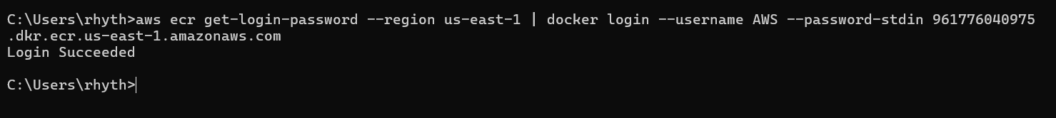
Step 4: Build Docker Image
Run this :
docker build -t devops-repo .
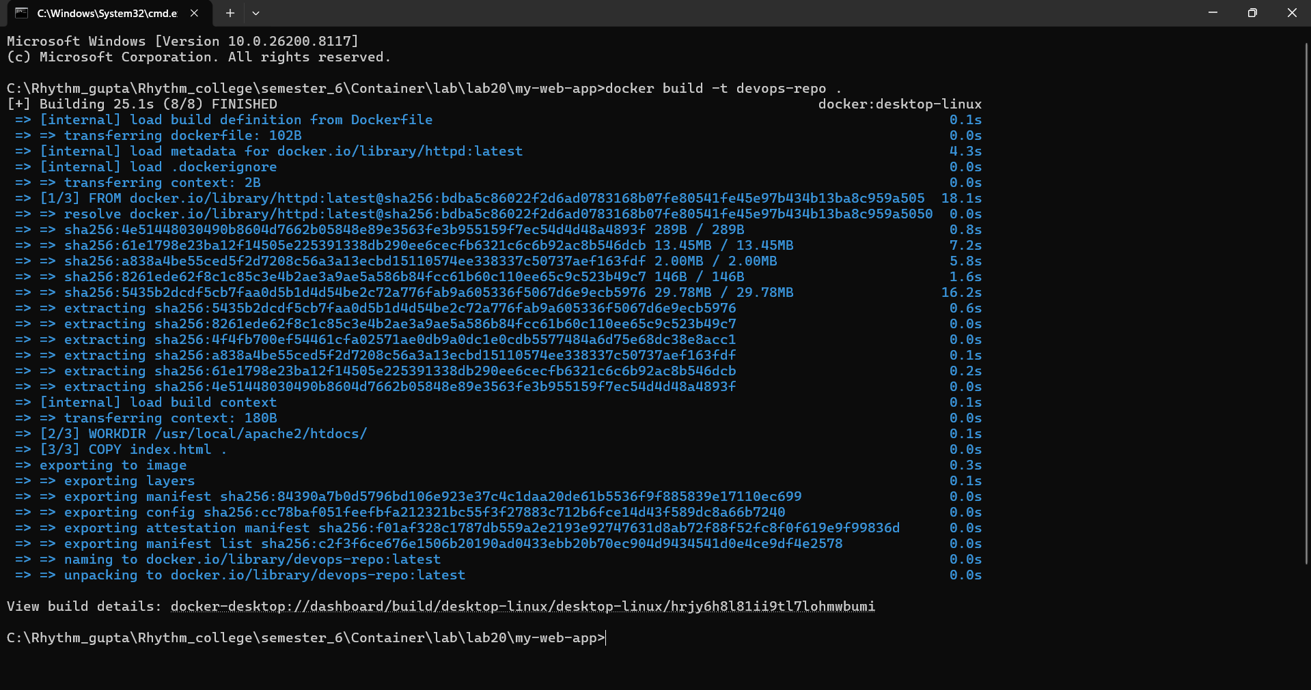
Step 5: Tag Docker Image
Run this :
docker tag devops-repo:latest 961776040975.dkr.ecr.us-east-1.amazonaws.com/devops-repo:latest

Step 6 : Push Docker Image
Run this :
docker push 961776040975.dkr.ecr.us-east-1.amazonaws.com/devops-repo:latest

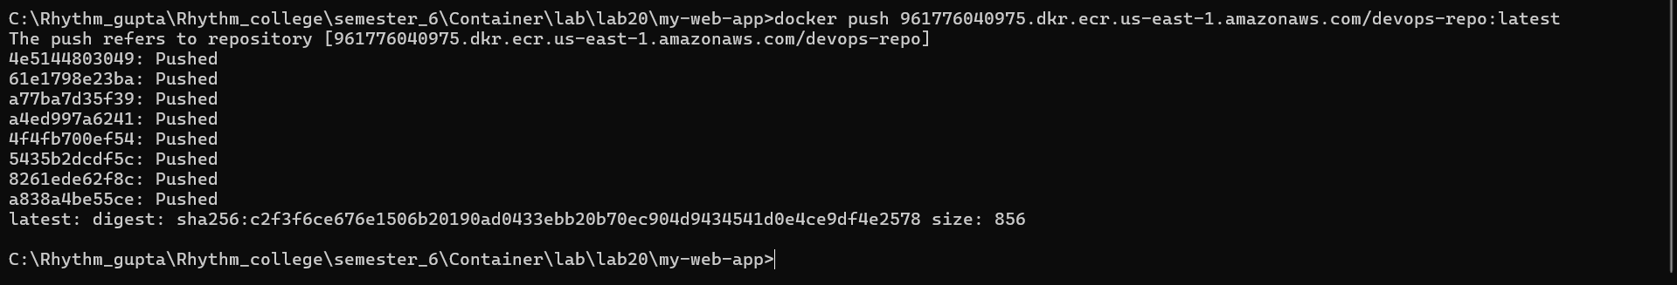
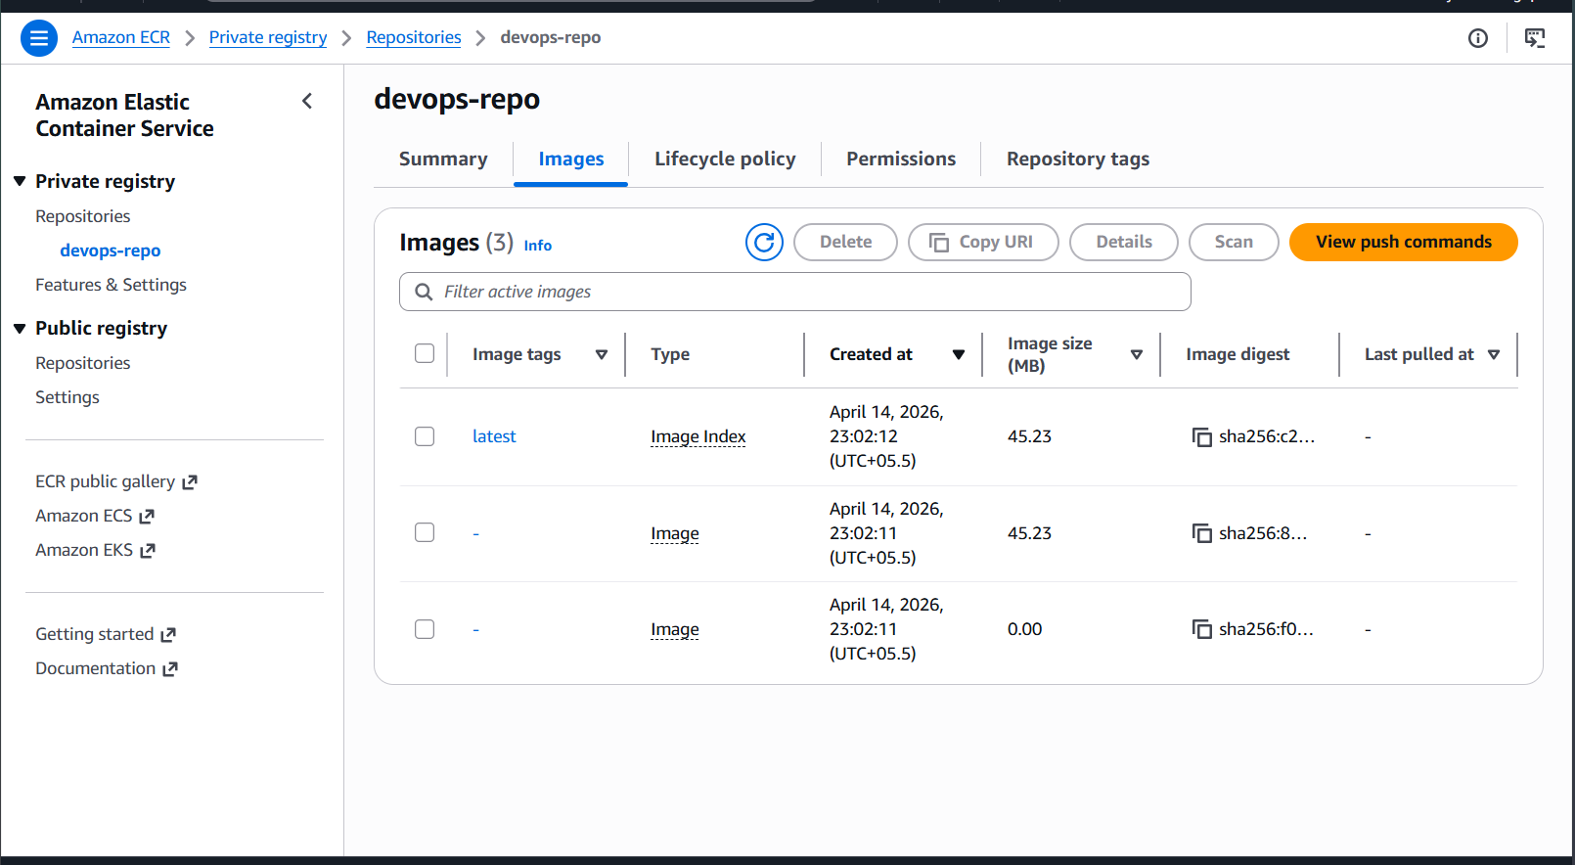

Step 7: Create Cluster
- Go to ECS
- Click Create Cluster
- Select Fargate (Serverless)
- Cluster Name: devops-cluster-new
- Click Create

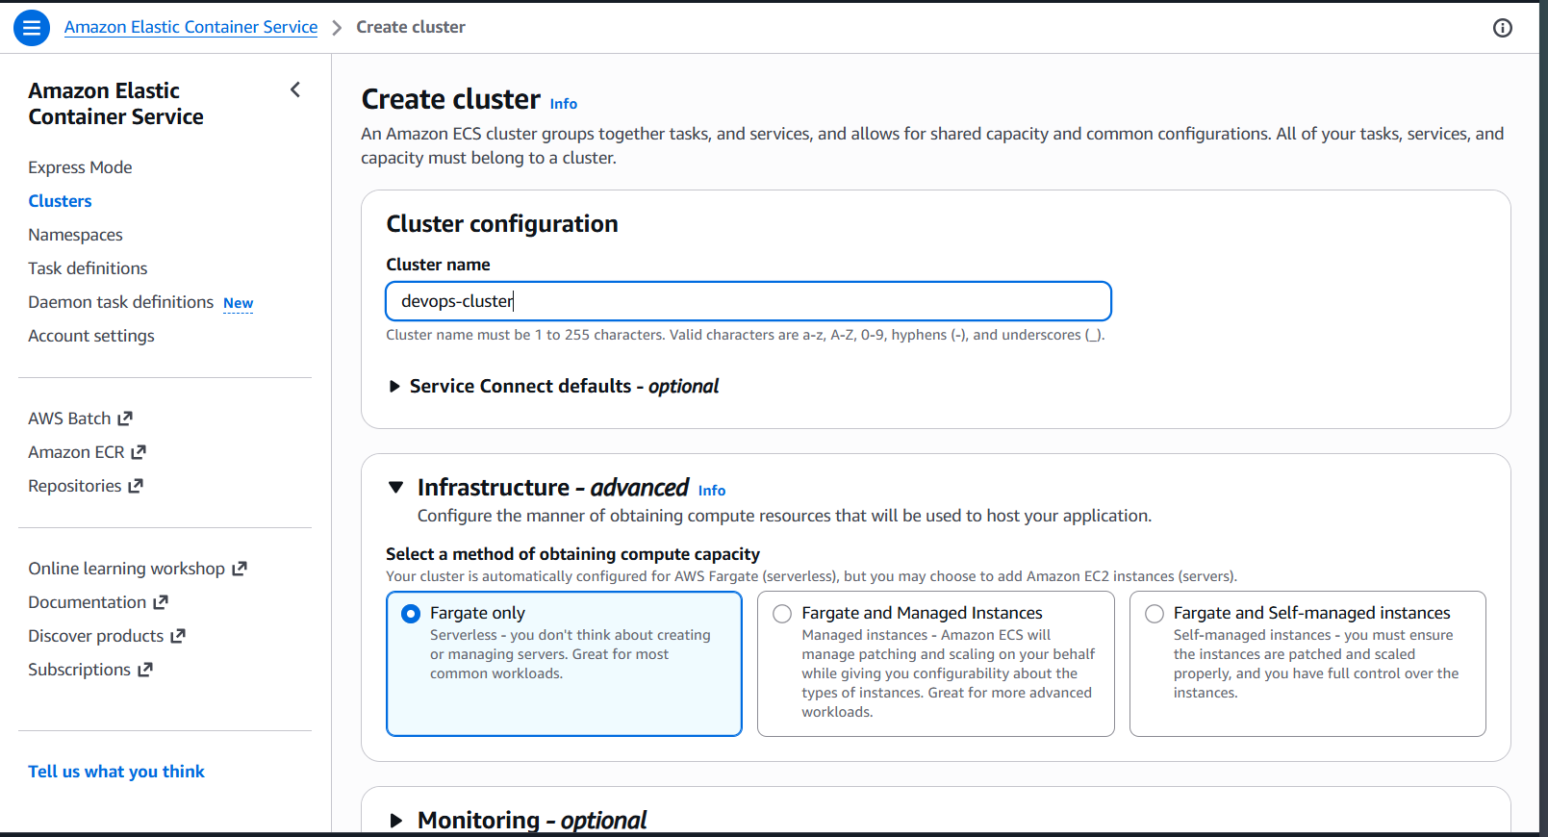

Step 8: Create Task Definition
- Launch Type → Fargate
- Container Image → Paste ECR URI

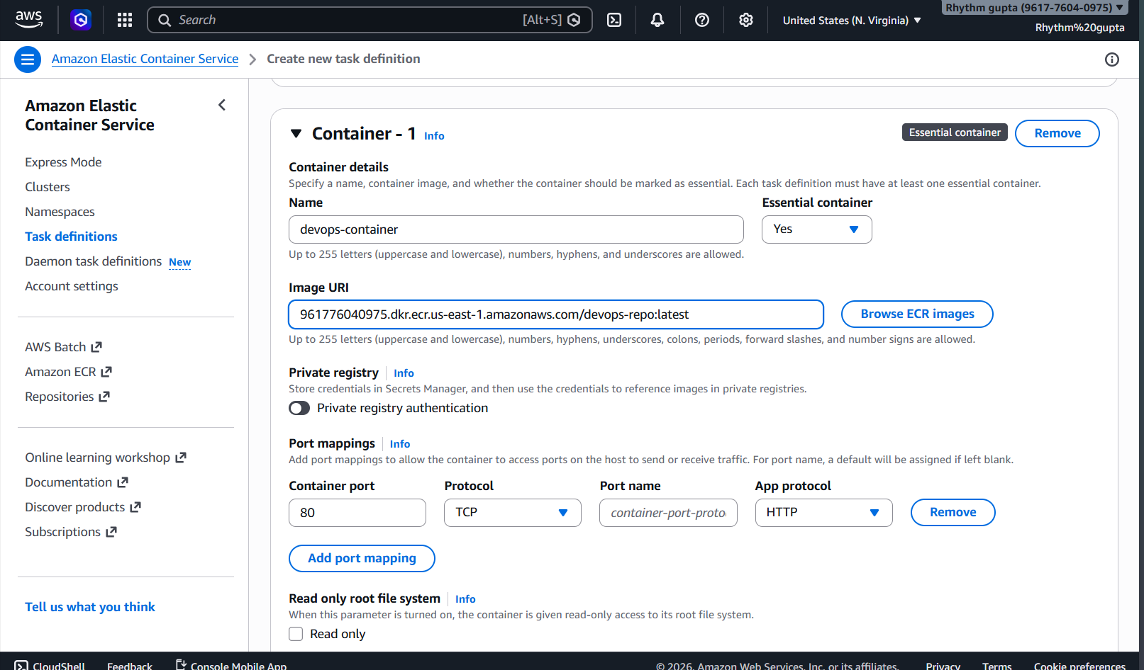

Step 9: Create Service
- Go to Cluster
- Click Create Service

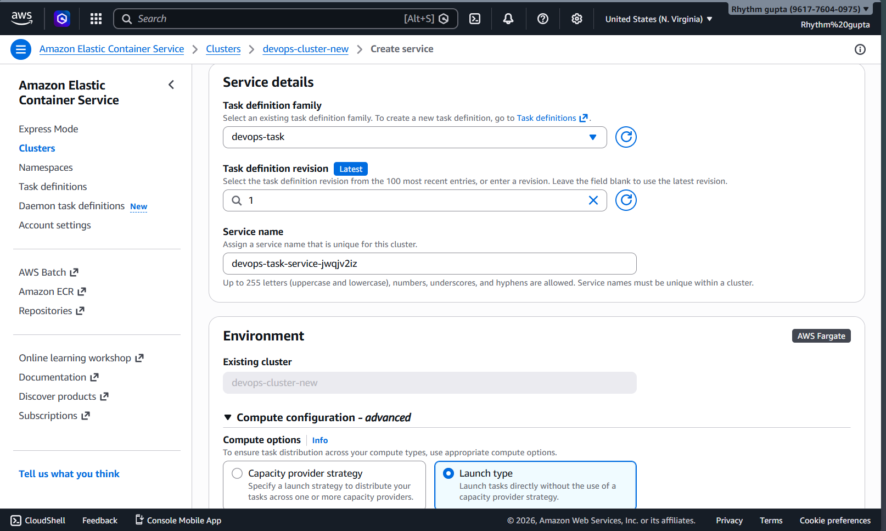

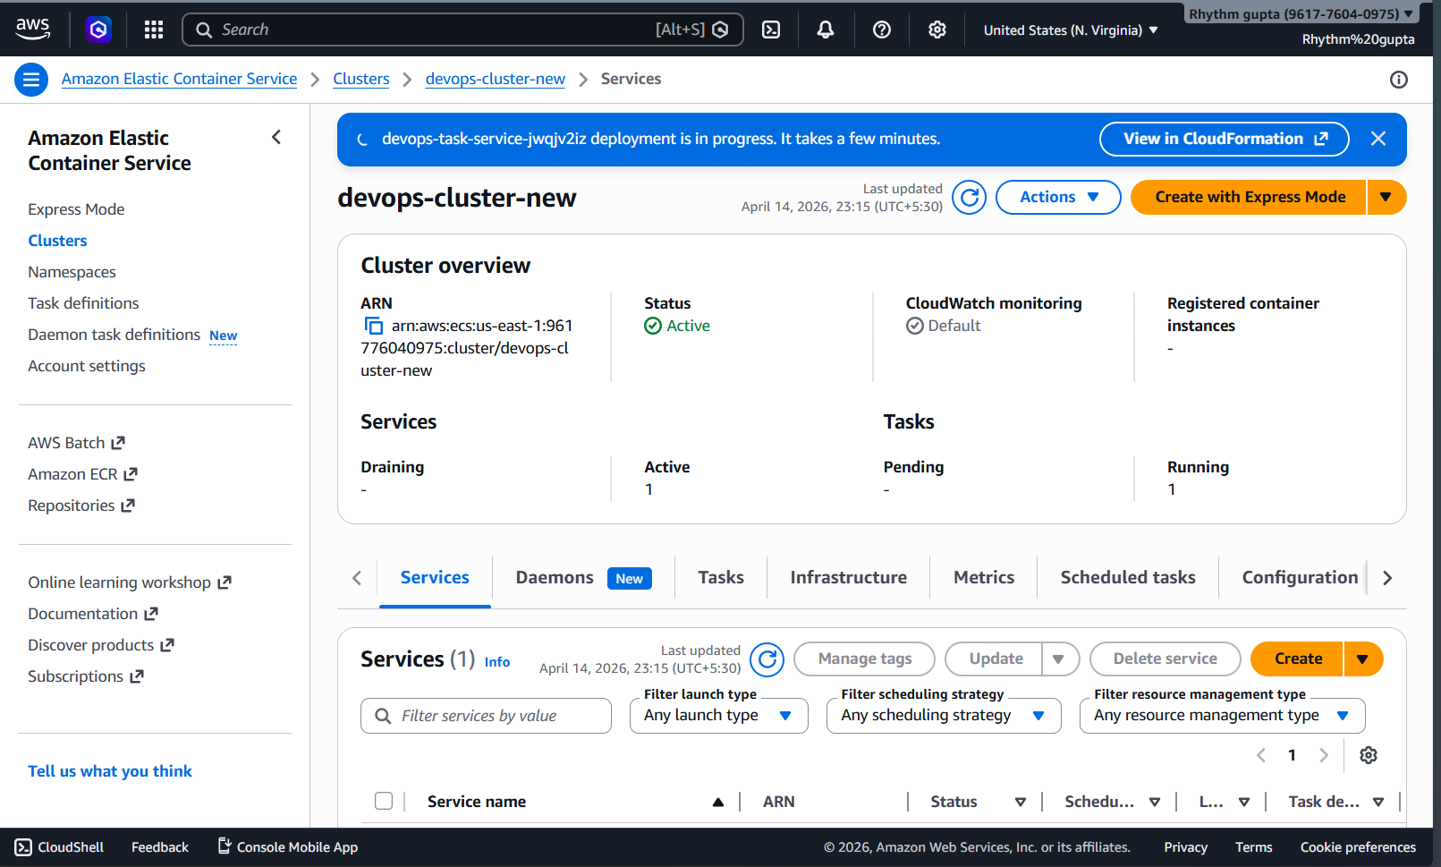

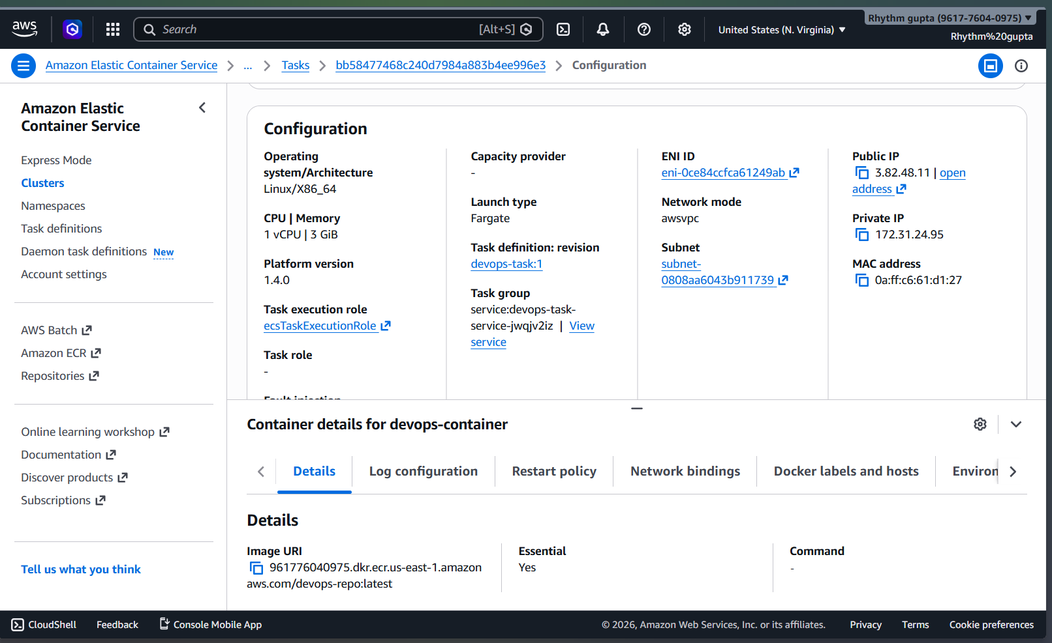

Step 10: Turn on all traffic in security broke
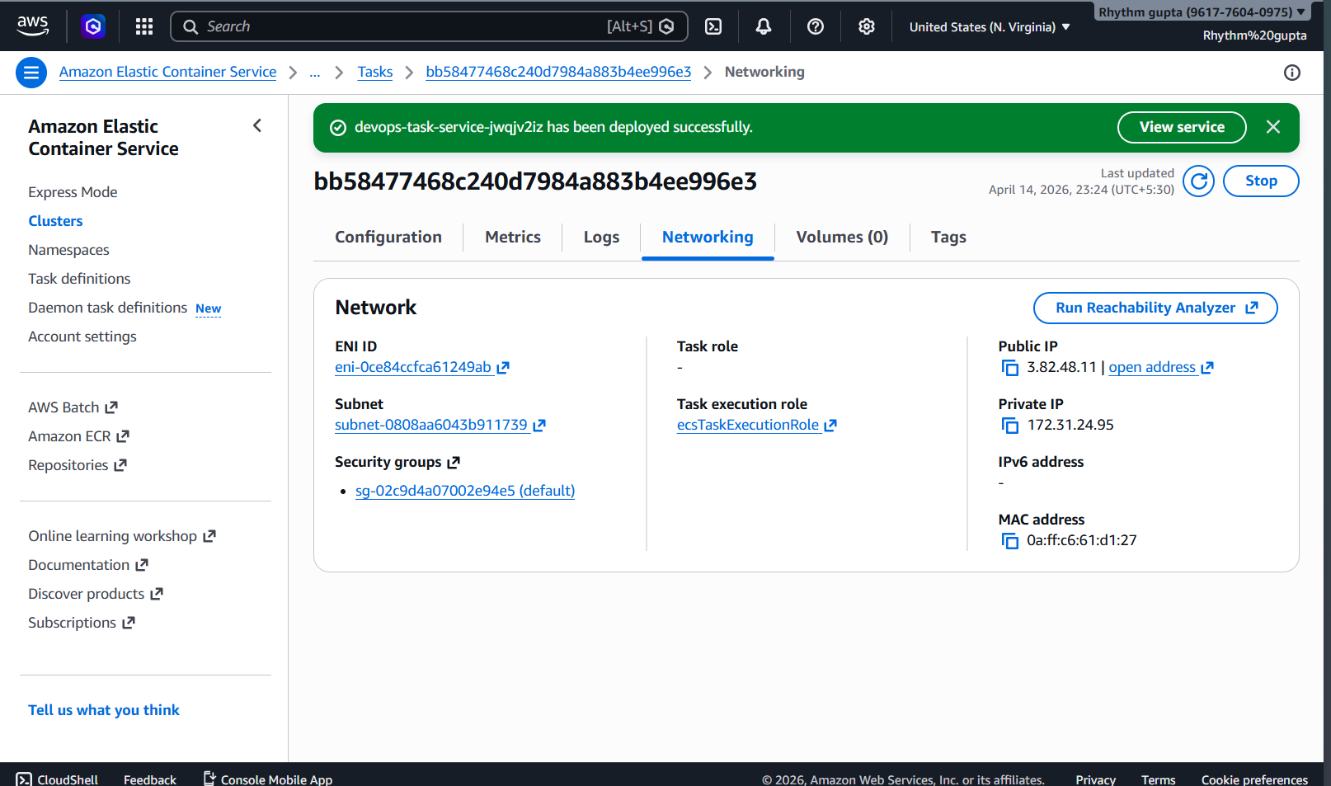
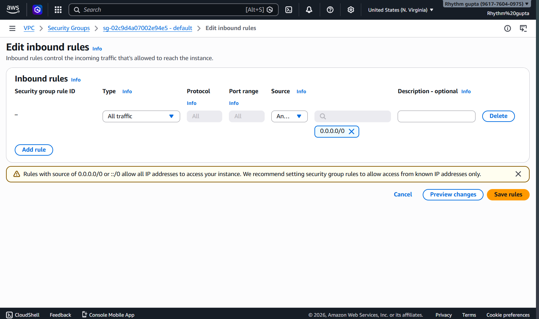

Step 11 : Verify Deployment
- Go to Load Balancer
- Copy DNS Name
- Paste in Browser

